PRIMIUM LACE WIG ORDER FORM
ORDER NO. Customer NUMBER Date
Hair Type [ ] Indian Remy Human Hair [ ] Brazillian Virgin Hair [ ] Chinese Virgin Hair
[ ] Malaysian Virgin Hair [ ] Mongolian Virgin Hair [ ] European Virgin Hair
Hair Texture & Curl
Hair Length Hair Color
Hair Density
Baby Hair [ ]
Type of Knots [ ] General Knots [ ] Bleached Knots [ ] Double knots

Cap Design

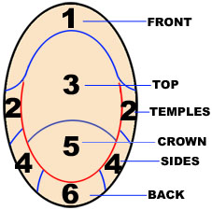 | Cap Design  [ ] Full Lace Wigs  [ ] With Stretch Lace in middle  [ ] With Stretch Lace ear to ear.  [ ] Without Stretch Lace.  [ ] Glueless cap design  [ ] Silk top 4”x4”  [ ] PU/Thin Skin Wigs  [ ] Weft hair extensions  [ ] Top closures  [ ] Lace frontals  [ ] Lace Front Wigs  Lace Color [ ] Transparent [ ] Medium Brown [ ] Light Brown  [ ] Dark Brown [ ] Pink [ ] Black  Lace Type  Specifications:
Please select or fill the cap size

[ ] Large [ ] Medium [ ] Small [ ] Customized

1  Circumference 2 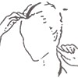 Front to Nape
3  Ear to ear across forehead 4 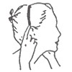 Ear to ear over top
5 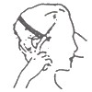 Temple to temple round back 6 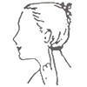 Nape of Neck

Size: 1 2 3 4 5 6
Special Instruction

